**Rockabill Film Society, Skerries**

**Autumn Season 2019**

### All films start at 8.30 pm in the Skerries Sailing Club. Tickets / membership at the door.

***Wednesday 25 September – Arctic***  
Dir: Joe Penna, 2018, Iceland, 98 mins Cert: CLUB  
Starring: Mads Mikkelsen, Maria Thelma Smáradóttir  
Language: English  
  
Full of shock turns, moments of horrific injury, polar bear action and tense emotional scenes, Arctic will keep your hands clenched to your chair until its brilliant, breathless conclusion. Mads Mikkelsen (Hannibal, Doctor Strange) gives a tour de force performance as a pilot whose plane has crashed in a remote corner of the Arctic. Stranded in the wilderness he uses his ingenuity to survive. When about to receive his long-awaited rescue, an explosive accident means his opportunity is lost and the dire situation further complicated. The tragic turn of events, involving another crash survivor forces the pilot to make a perilous choice between the relative safety of his camp and a deadly trek into the unknown.

***Wednesday 9 October – Float Like a Butterfly***  
Dir: Carmel Winters, 2018, Ireland, 101 min, Cert: 15A

Starring: Hazel Doupe, Dara Devaney, Johnny Collins, Hilda Fay, Lalor Roddy

Language: English

[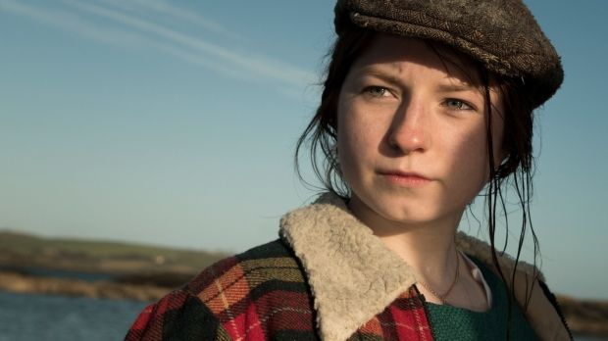](https://1.bp.blogspot.com/-B6mypAmtdaI/XX_jtuIHsFI/AAAAAAAAEqU/6zBYTew91ks-S7kHADWM9OrVn1-EmXTjgCLcBGAsYHQ/s1600/flb.jpg)

We have the opportunity to screen 'Float Like a Butterfly' starring Hazel Doupe from Skerries and a pupil of Skerries Community College!

Winner of the Audience Award at the Cork Film Festival November 2018.

15-year-old Frances lost her mother in a fight. The same fight which led to her father being locked up in jail for the last ten years. Frances has never forgiven the police sergeant who she feels is responsible for this. She’s got fighting in her blood, just like her idol Muhammad Ali. And like Ali, she wants to be the Greatest too.

When her father gets out of jail, Frances is starry-eyed. Together they can take on the world. But her father doesn't turn out to be the hero she remembers. Required to keep the peace due to the conditions of his parole, he's forced to endure humiliation from the police sergeant, much to Frances' dismay. And to make up for lost time, he is determined to make a man of his son and an obedient wife of his daughter.

Frances never wanted to clash with her beloved father, but when he gives her boxing gloves to a prospective husband to “keep her in line” she has to make a stand. Cast out by the world and her family alike, Frances must fight even for the right to fight. Some people say it doesn’t matter whether you win or lose. But for Frances losing is not an option. This is a fight she has been training for all her life. At stake is her own freedom, her mother's honour and her father's faith. She knows the only way she can end this war is to win it. – *Screen Ireland*

[](https://1.bp.blogspot.com/-1pEnseMRexE/XX_O-4ssJrI/AAAAAAAAEpc/UwNbt1QBrPQgFWdm0yfc7h1X1D6AdfRLQCLcBGAsYHQ/s1600/sinkswim.jpg)***Wednesday 23 October – Sink or Swim***  
*Le Grand Bain*

Dir: Gilles Lellouche, 2018, France, 122 mins, Cert: 15A

Starring: Mathieu Amalric, Guillaume Canet, Benoît Poelvoorde,Jean-Hugues Anglade, Virginie Efira  
Language: French

A group of 40-something guys, all on the verge of a mid-life crisis, decide to form their local pool’s first ever synchronized swimming team – for men. Braving the skepticism and ridicule of those around them, and trained by a fallen champion trying to pull herself together, the group set out on an unlikely adventure, and on the way will rediscover a little self-esteem and a lot about themselves and each other. – *Cannes Film Festival 2018*

***Wednesday 6 November – The Favourite***  
Dir: Yorgos Lanthimos, 2018, Ireland, UK, USA, 119 mins Cert:15A

Starring: Olivia Coleman, Emma Stone, Rachel Weisz  
Language: English

Yorgos Lanthimos’s (The Lobster, The Killing of a Sacred Deer) outrageous period comedy stars an enviable assemble cast of Emma Stone, Oliva Colman and Rachel Weisz.

A frail and capricious Queen Anne (Colman) governs an 18th Century England at war with France. At her side is Lady Sarah (Weisz), her carer, confidant, lover and de facto ruler of England. As the politics of war consume Lady Sarah, a new servant to the Queen, Abigail (Stone), cunningly usurps the beleaguered Lady Sarah.

Illuminated by outstanding performances from Colman, Weisz and Stone, each portray complex, flawed, entirely distinctive women. The Favourite is a black comedy about status and power, it is at times bizarre but always utterly distinct.



*“A perfectly cut diamond of a film”* – Owen Gleiberman, Variety

*“Fabulously entertaining, sumptuously crafted, delectably witty”* – David Rooney, Hollywood Reporter.

*“A Crowning Achievement. A Royal period piece led by the majestic triumvirate of Oliva Colman, Emma Stone and Rachel Weisz”* – Michael Nordine, Indie Wire

*Venice Film Festival 2018 – Winner Grand Special Jury Prize Yorgos Lanthimos*

*Venice Film Festival 2018 – Winner Volpi Cup Best Actress Olivia Colman*

***Wednesday 20 November – Foxtrot***

Dir: Samuel Maoz, 2017, Germany, France, Israel, Switzerland, 113 mins, Cert: 15A

Starring: Lior Ashkenazi, Sarah Adler, Yonatan Shiray, Karin Ugowski

Language: Hebrew

This emotional knockout from Israel isn’t nominated for Best Foreign-Language Film at the 2018 Oscars – another strike to add to the tally of Academy cock-ups. From first shot to last, *Foxtrot* takes a piece out of you. Director Samuel Maoz (Lebanon) begins with a devastating moment of grief: Soldiers arrive at the home of a middle- aged couple to tell Dafna (Sarah Adler) and Michael Feldman (Lior Ashkenazi) that their son has been killed in the line of duty. As his mother is tranquilized, his father is told about funeral arrangements. The military ritual is tragically commonplace. But for Michael, the sudden desolation is impossible to process. After calling his Auschwitz- survivor mother (Karin Ugowski), he locks himself in the bathroom, his face ravaged with anguish, pouring scalding water on his hands. Ashkenzai, a superb actor, reaches a new career peak. You will be shaken.

In the film’s second section – there are three – Maoz switches focus to four Israeli soldiers on border patrol in the desert. Jonathan (Yonatan Shiray), the Feldmans’ son, is one of a group manning a security checkpoint. We watch the young soldiers sleep in a large shipping container and fight off boredom with talk, video games, even a little soft-shoe. Maoz and the gifted cinematographer Giora Bejach turn the desert into a dream-like landscape where a camel can walk through a security gate and Jonathan can grab a rifle and use it as a dance partner. The mood is broken when Palestinians attempt to cross and suffer humiliating interrogations. It does not end well.

[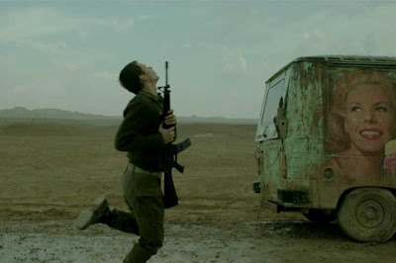](https://1.bp.blogspot.com/-3zNMaYMethg/XX_gaBabPfI/AAAAAAAAEp8/nK3c22KAEYYzKD4BlY5Qz4TALWy5-ntIwCLcBGAsYHQ/s1600/foxtrot.jpg)In the final third, we’re back in the Feldman apartment, where a personal war is raging between Michael and Dafna. Moaz builds his film out of puzzle pieces that don’t easily fit together. But there’s no mistaking the writer-director’s anger at his country for sending soldiers to die for questionable politics. That anger has brought accusations against the movie’s supposed “anti-Israel narrative.” Is it that or more likely a humanist plea for change directed at any country that extends war and ignores its futility? You be the judge. *Foxtrot* makes demands on audiences and then richly rewards them. It’s a riveting, deeply resonant achievement.

*- Peter Travers, Rolling Stone*

***Wednesday 4 December – Wild Rose***  
Dir: Tom Harper, 2018, UK, 101 mins, Cert: 15A  
Starring: Jessie Buckley, Julie Walters, Sophie Okonedo  
Language: English

[](https://1.bp.blogspot.com/-iuR4FVQk4wQ/XX_hqODv4EI/AAAAAAAAEqI/u78O1IM4byUZDmyLeSJodY2K5Gp_3R6kQCLcBGAsYHQ/s1600/wildrose.jpg)

Kerry native and BAFTA Rising Star nominee, Jessie Buckley (Beast), stars as Rose-Lynn Harlan, a single mother of two, fresh out of jail, whose dream is to leave her native Glasgow and make it as a country singer in Nashville. Her mum Marion (Julie Walters) has lost her patience with Rose-Lynn and would love for her daughter to settle down and to create a home for her family.

The effervescent and cheeky Rose-Lynn, possesses a raw, powerful and talented voice. Buckley whose natural singing voice shines in this boisterous story of self-discovery, played to the tune of three chords and the truth. Wild Rose is an enchanting story about how growing up does not mean giving up on ones dreams.

*“… Director Tom Harper and screenwriter Nicole Taylor have fashioned something entirely delightful, fresh as a Scottish summer evening.”* - Leslie Felperin, Hollywood Reporter

*“If a star was born with Jessie Buckley in Beast, then Wild Rose marks her ascendency.”* - Fionnuala Halligan, Screen International